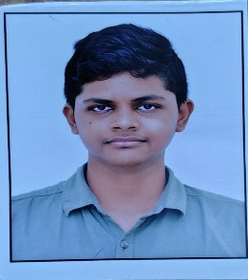
N. Devendra Sai
Web Developer | Student | Programmer
📧 Email: deva77486@gmail.com
📞 Phone: +91 7989707730
📍 Location: India

CAREER OBJECTIVE
To obtain an entry-level position where I can apply my knowledge of HTML, CSS, and basic JavaScript, enhance my technical skills, and contribute to the growth of the organization.

EDUCATIONAL QUALIFICATIONS
- Bachelor’s Degree (Pursuing)
Madanapalle Institute Of Technology
- Intermediate / Diploma
College Name
Year: 2024
- SSC
School Name
Year: 2022

TECHNICAL SKILLS
- HTML5
- CSS3
- JavaScript (Basics)
- C / Python / Java (Basics)
- MS Word, MS PowerPoint

PROJECTS
1. Personal Portfolio Website
- Designed and developed a personal portfolio using HTML and CSS
- Included sections like About, Skills, Projects, Resume, and Contact
2. Simple Calculator
- Built a basic calculator using HTML, CSS, and JavaScript
- Performs basic arithmetic operations

STRENGTHS
- Quick learner
- Problem-solving skills
- Good communication
- Teamwork and adaptability

HOBBIES
- Learning new technologies
- Browsing tech content
- Coding practice

DECLARATION
I hereby declare that the above information is true and correct to the best of my knowledge.
Place: Angallu
Date: 26-01-2026
Signature:
(N. Devendra Sai)

